Xidian University & Heriot-Watt University

**Diodes and BJT applications**

(Lab 3)

Semiconductor Electronics

Xunchi Ma

21012100015

2023-12-20

**Task 1: Simulation of Diode Circuit**

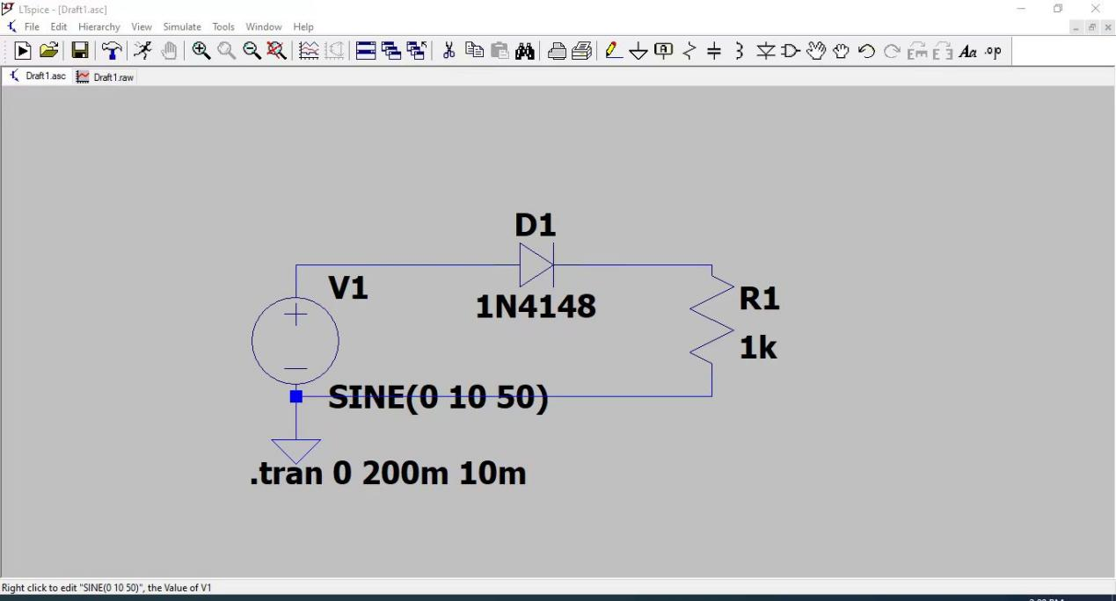

Figure1.1 the schematic of the circuit

**Short Introduction on the circuit purpose and operation.**

The purpose of the circuit is constructing a half-wave rectifier which eliminate the negative value of the input signal and only keep the positive one.

When in positive circle, the diode is in positive bias, the source and load are short connected(ideal diode). When is negative circle, the diode is in reverse bias, the source and load are disconnected(ideal diode).

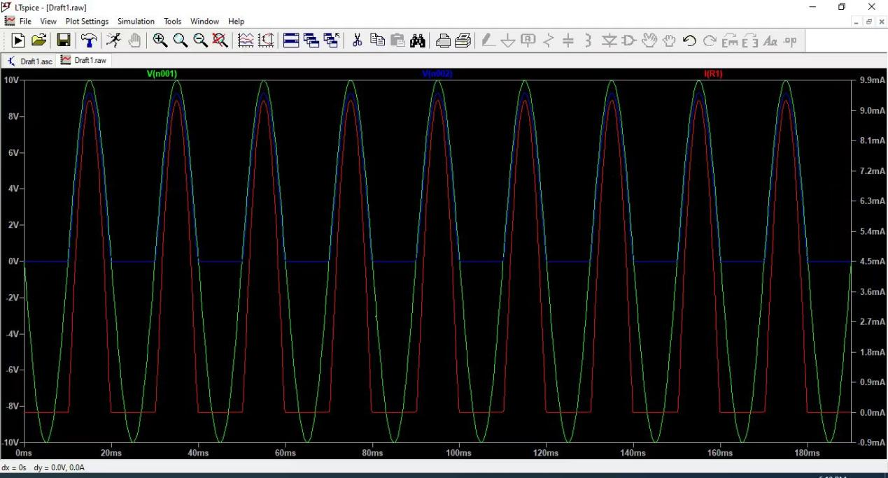

Figure1.2 input and output waveforms (1)

**Findings from the initial simulation with input and output waveforms.**

it can be observed from the simulation result that:(green:input voltage; blue: output voltage; red: output current), only the positive circle of the input waveform is kept.

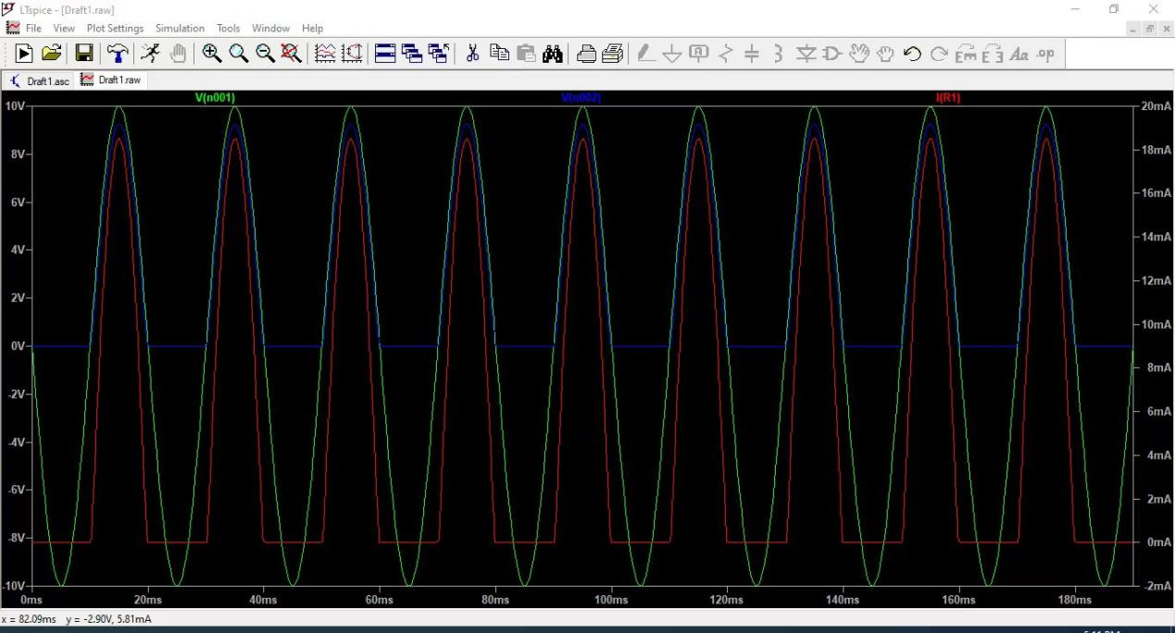

Figure1.3 input and output waveforms (2)

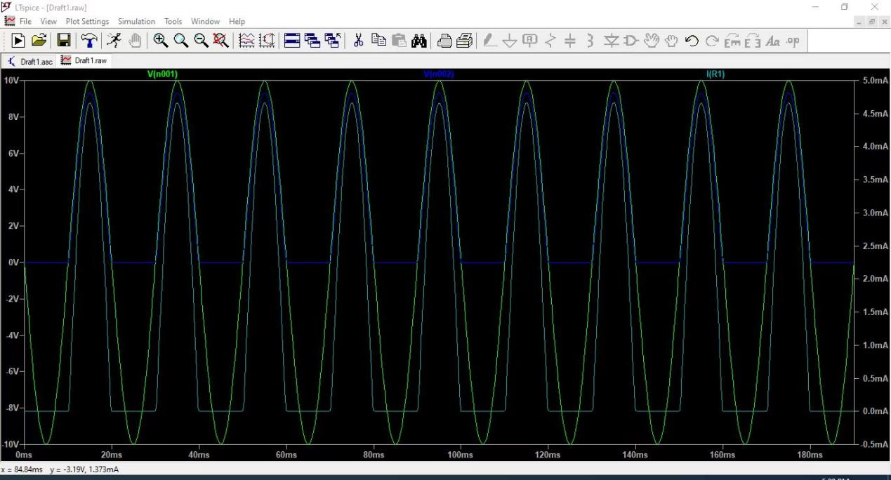

Figure1.4 input and output waveforms (3)

**The effect of change in load resistance value, using 3 different values for (RL) of your selection.**

After trying the other two load resistance value, it can be found that the input voltage doesn’t change a lot. Only the current passing the load will vary according to the ohm’s law.

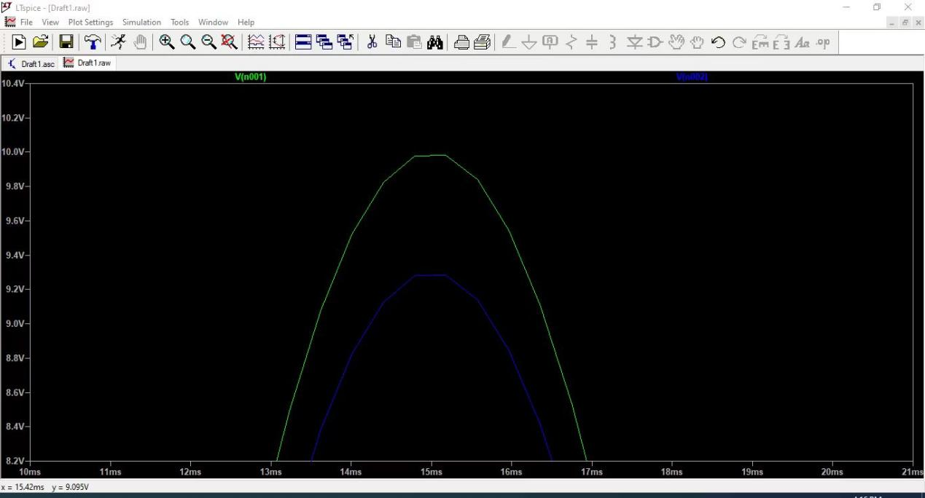

Figure1.5 the voltage drop of the diode

**Looking at the output, is 1N4148 a silicone or Germanium diode? and why?**

It is obvious from the figure that the voltage drop 0.7V, which is corresponding to the Silicon diode.

**Discuss the effect on the output if the diode was replaced with an ideal diode.**

There will be zero voltage drop across the diode, the input and output waveforms will overlap.

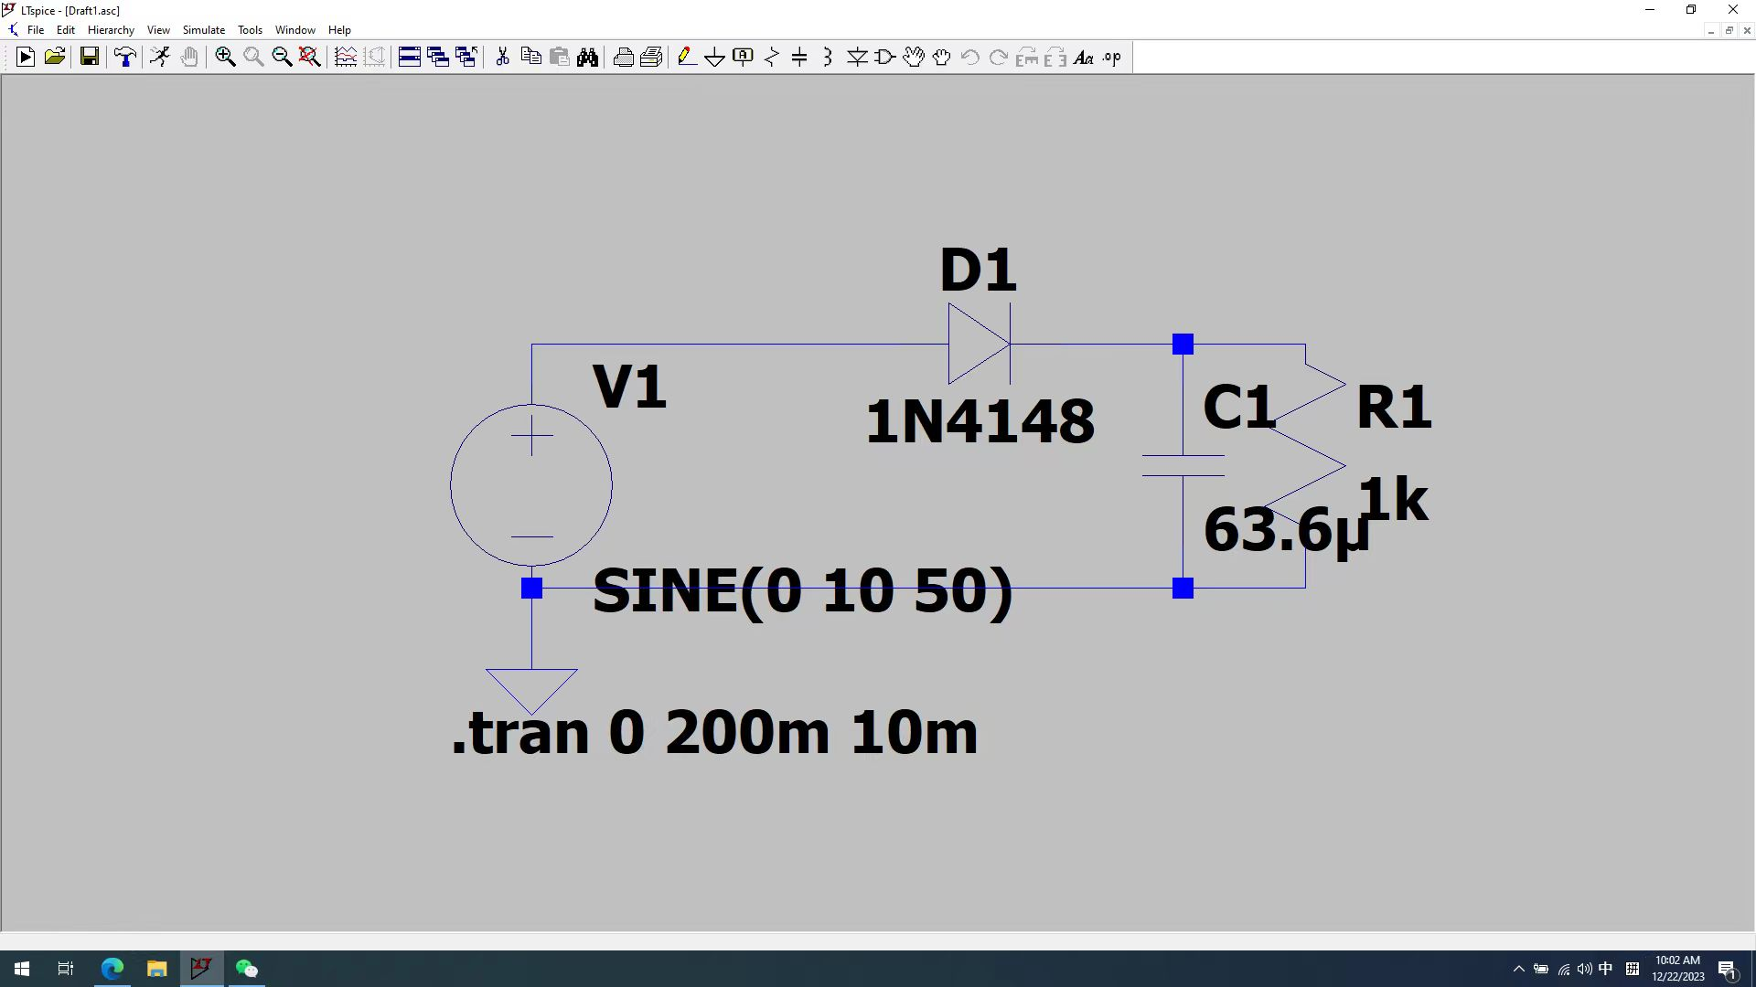

Figure1.6 the improved circuit

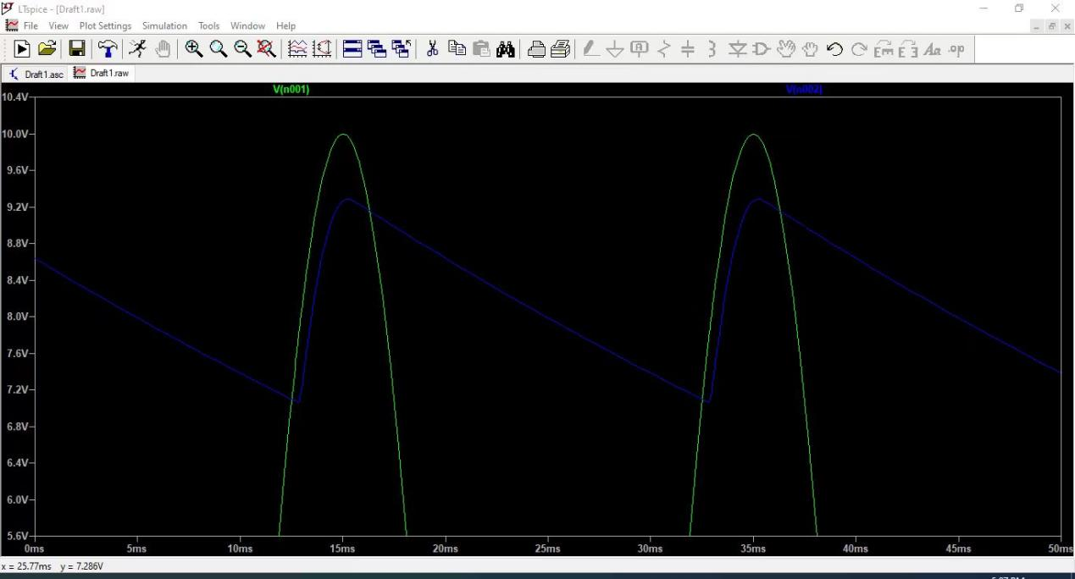

Figure1.7 output waveform (zoomed)

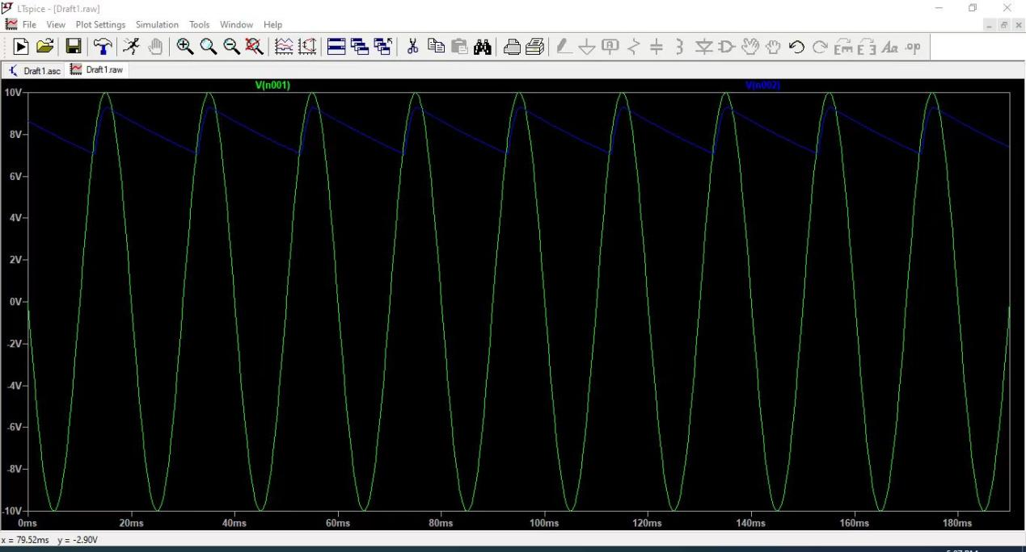

Figure1.8 output waveform

**Propose a modification to this circuit (using only one new component) to improve its output and elevate its output average value, including detailed coverage of your proposal, supported with simulation results, and comparison to the initial output. Any component selection must be clearly presented and justified.**

by adding a single capacitor as a filter, the capacitance can be calculated from the formula:(assuming the ripple voltage is 1V)

the simulation result shows that the modified circuit improved the output waveform and its average value compared with the initial output.

**Task 2: Design and Simulation**

**A description of the circuit purpose and operation.**

According to the input and output waveforms, it is a clipper. It limits the maximum output value of the waveform.

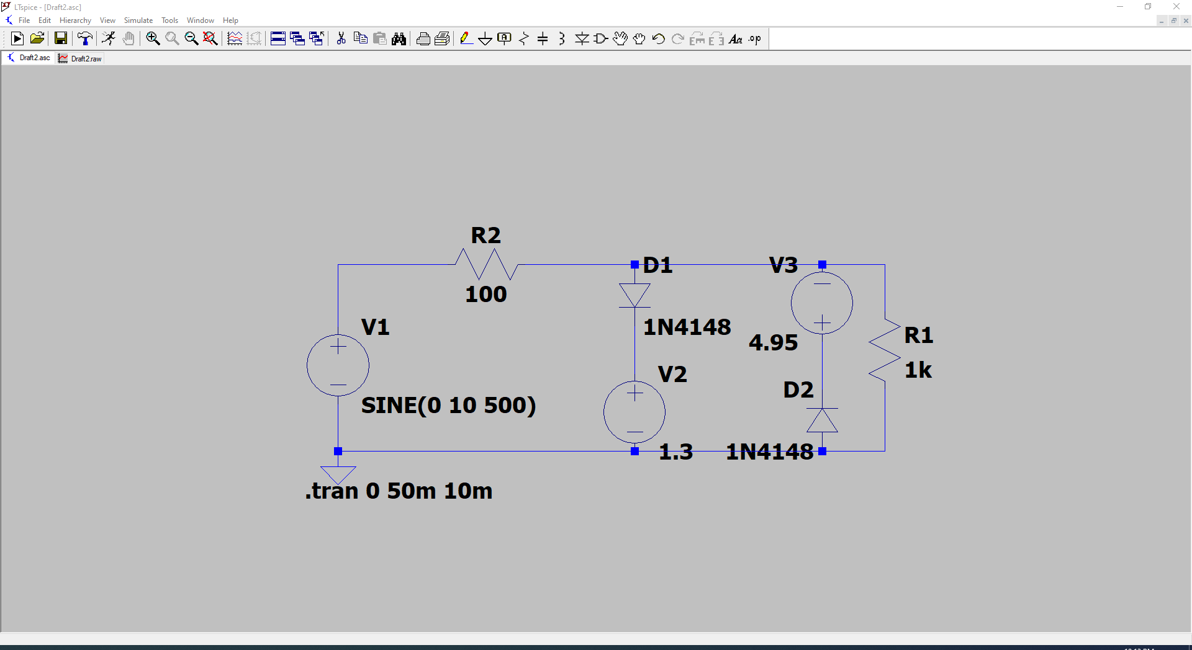

Figure2.1 schematic of the circuit

**Complete documentation of your design approach and justified component**

**selection that includes the diode and its model number, other components, and**

**their values.**

All the model number and the value of the components are presented on the schematic.

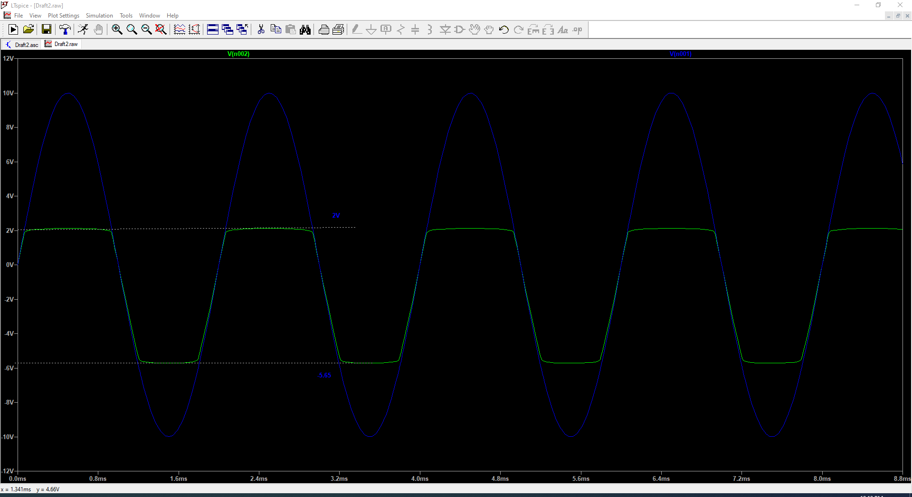

s

Figure2.2 input and output waveforms

**Simulation results of your proposed design showing input of 10Vp 500Hz sine**

**wave and how the output compares to the one presented in Figure T3.**

According to the simulation results, the Figure 2.2 is very close to the Figure T3.

**Task 3: Simulation of BJT Circuit**

**Short Introduction on the circuit purpose and operation**

The circuit act as an amplifier, whose output waveform is a certain gain of the input waveform.

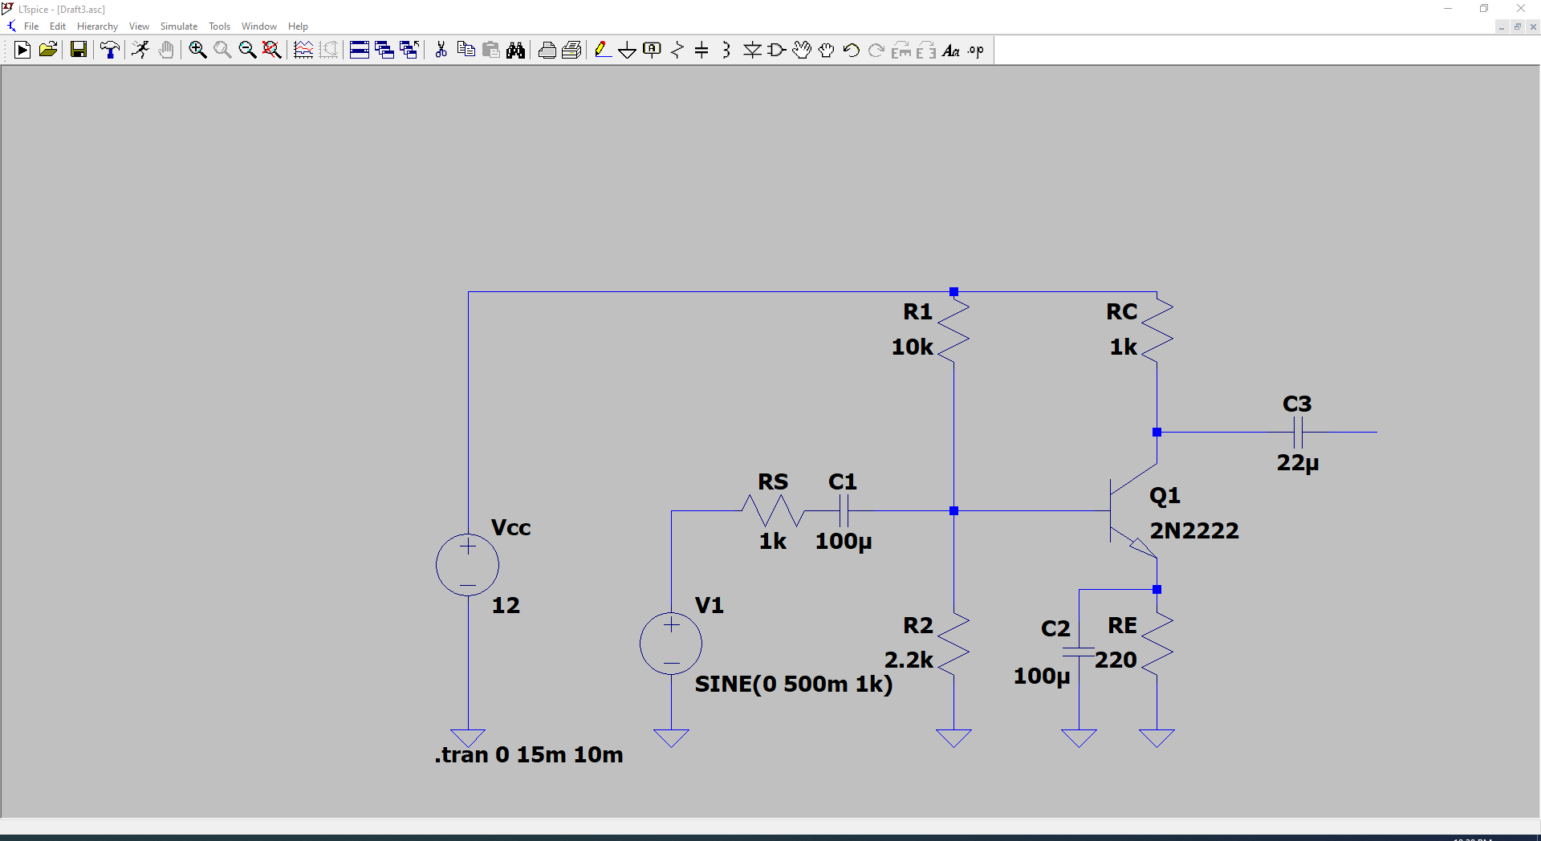

Figure3.1 schematic of the circuit

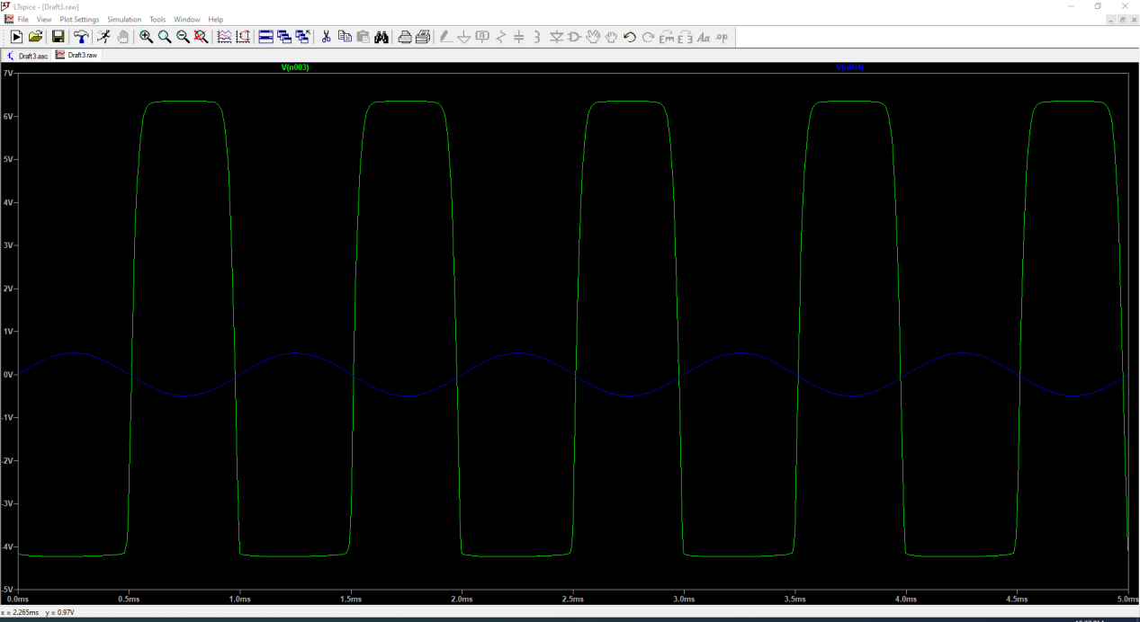

Figure3.2 input and output waveforms

**Findings from the initial simulation with input and output waveforms.**

It can be observed from from the input and output waveforms that the output waveform is way more larger than the input waveform. Cause the output waveform reaches the saturation region of the amplifier, the peak of the waveform is clipped.

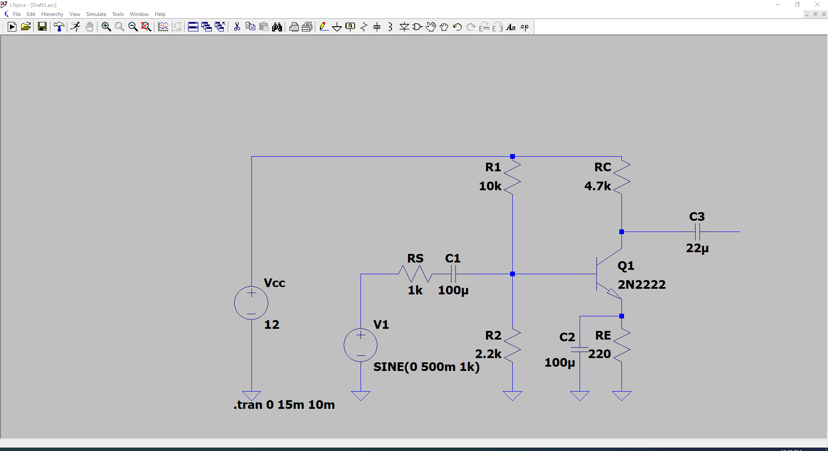

Figure3.3 schematic of the circuit(Rc=4.7k)

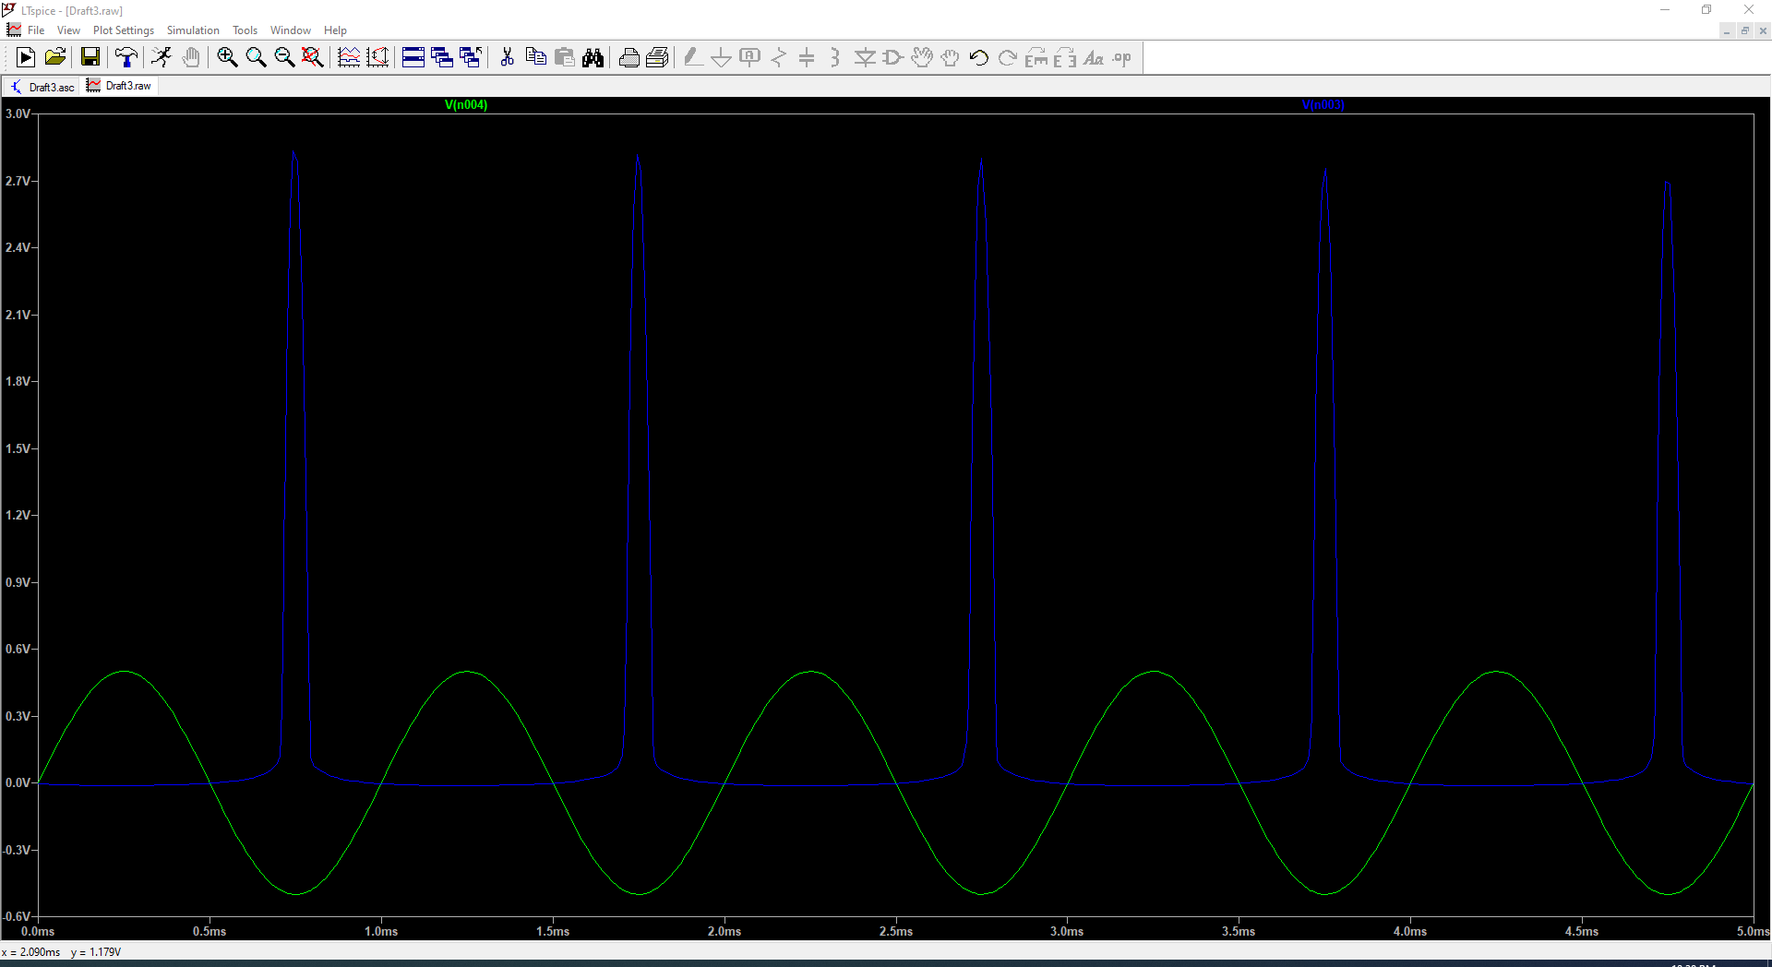

Figure3.4 input and output waveforms(Rc=4.7k)

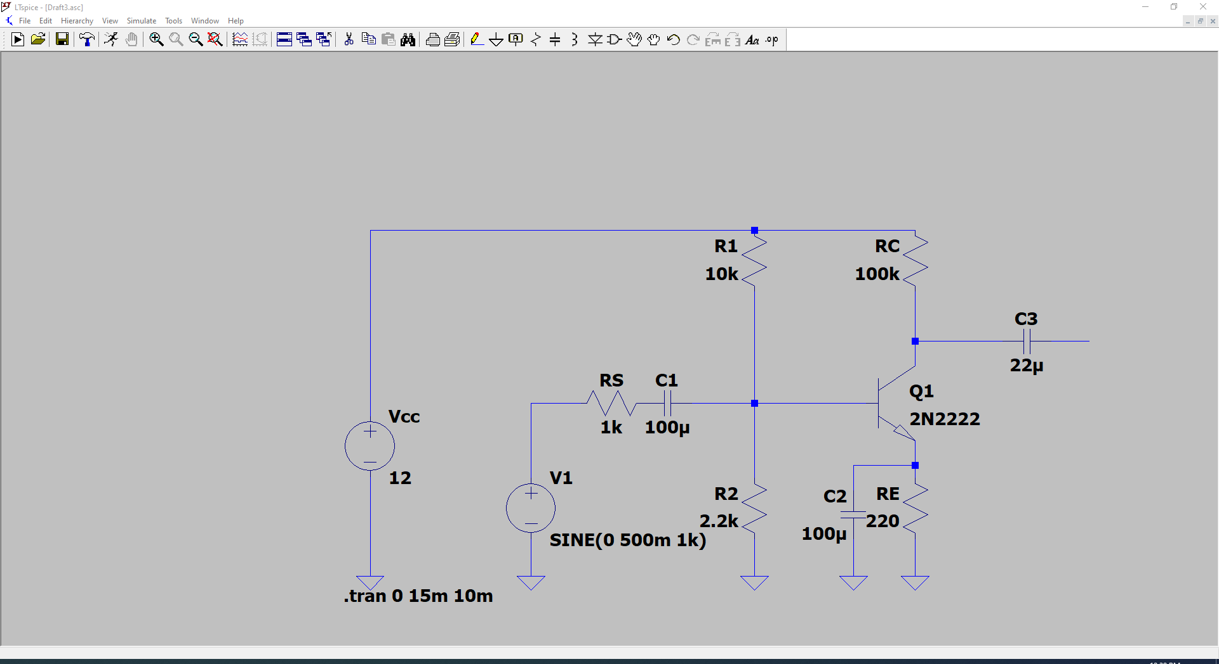

Figure3.5 schematic of the circuit(Rc=100k)

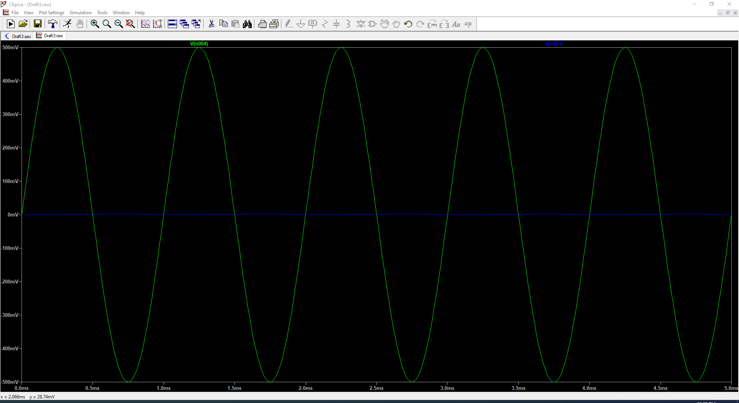

Figure3.6 input and output waveforms(Rc=100k)

**The effect of change in RC on the circuit output with gain calculation on each of**

**the three used values.**

With the resistance of Rc going up, the transistor is gradually cut off. At Rc=4.7k, the 2N2222 is partially cut-off, leaving some glitch as the output waveform.At Rc=100k, the transistor is totally cut-off, there is nearly no output signal.

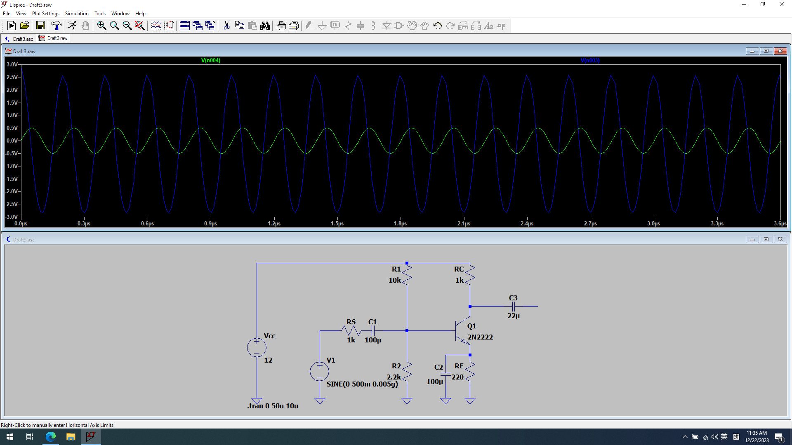

Figure3.7 schematic of the circuit(Freq=5Mhz)



Figure3.8 input and output waveforms(Freq=5Mhz)

**What would happen if you change the input frequency to 5MHz? and why?**

input signal frequency exceeds the transistor's transition frequency (fT), the gain will drop significantly, and the amplifier may not function effectively.

There may also be issues with circuit stability, as the phase response of the circuit can lead to oscillations at high frequencies if not properly designed.